DBMS PROJECT

Title: Library Management System

Team Members:

Sai Rahul Nallapareddy(RA1911003010889)

Prabhat Kumar(RA1911003010896)

Maganthi Trinadh(RA1911003010903)

Abstract:

A library management system is software that is designed to manage all the functions of a library. It helps librarian to maintain the database of new books and the books that are borrowed by members along with their due dates. This system completely automates all your library’s activities. The best way to maintain, organize, and handle countless books systematically is to implement a library management system software. A library management system is used to maintain library records. It tracks the records of the number of books in the library, how many books are issued, or how many books have been returned or renewed or late fine charges, etc.

ER Diagram

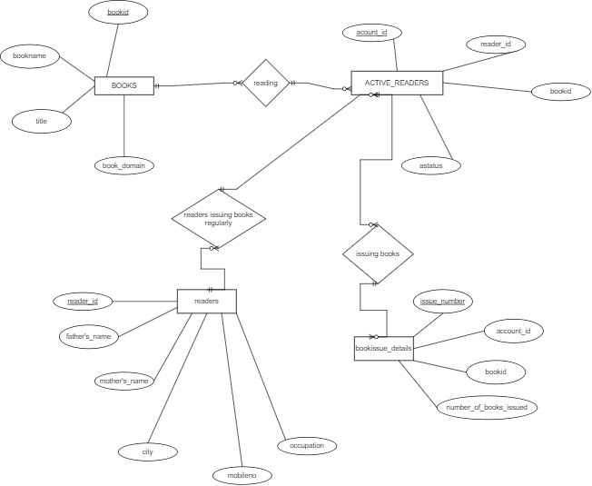

Database Model

